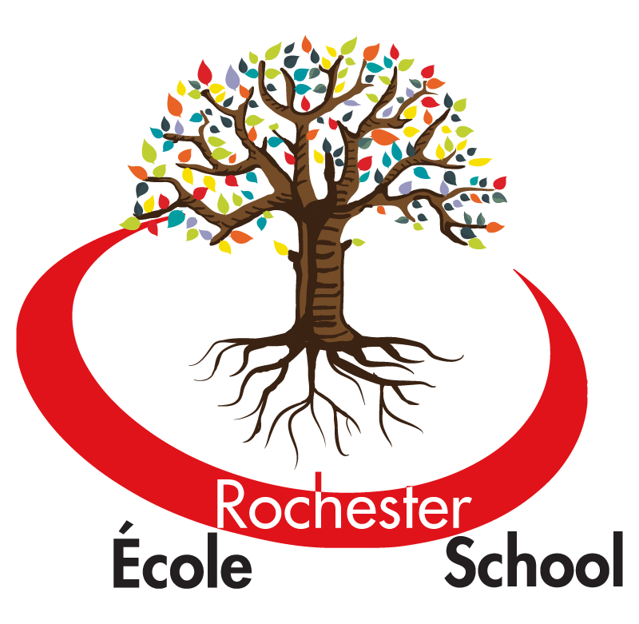
ÉCOLE ROCHESTER ELEMENTARY SCHOOL
411 Schoolhouse Street
Coquitlam B.C.
V3K 4Y7
(604) 939-4624
rochester@sd43.bc.ca

2016-2017 School Year

Coquitlam RCMP
2986 Guildford Way
Coquitlam, B.C.

To whom it may concern:

The individual before you will be volunteering at our school. In order to fulfill the requirements for school volunteers in School District #43 (Coquitlam), he/she requires a free Criminal Record Check.

If you have any questions regarding this individual’s application for a criminal record check please contact me at 604- 939-4624.

Thank you for your assistance.

John Goheen – Principal
Rochester Elementary School
411 Schoolhouse Street
Coquitlam, BC
V3K 4Y7

